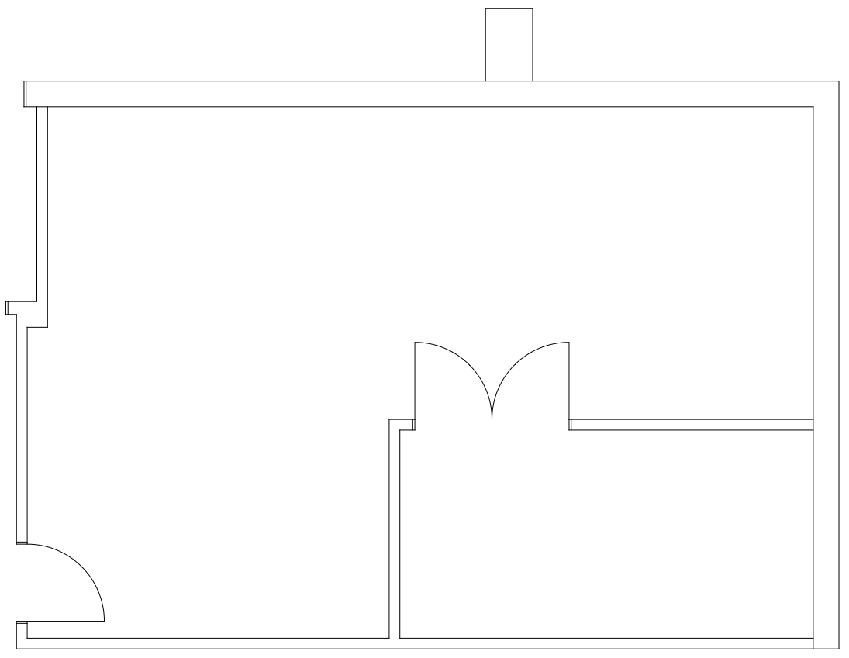

759 sq. ft. Available For Lease
5601 S. Broadway – Suite 090
For Leasing Information Contact:
Ken Good
Good Signature Management
(720) 588-4663
ken@goodsignature.com
www.goodsignature.com

